AIM: To create an automated system to perform E-ticketing.

PROCEDURE: (I) PROBLEM STATEMENT
The project is carried out to develop software for online Railway Reservation System. This system has various options like reservation, cancellation and to view details about available seats. The project mainly simulates the role of a Railway ticket booking officer, in a computerized way. The reservation option enables a person to reserve for a ticket at their home itself.All he/shehas to do is to just log in and enter the required details. After this the reservation database is updated with the person details, train name and also the source and destination place. The cancellation option enables the passenger to cancel the tickets that has been already booked by him/her. The availability option prompts the person to enter train number, train name and date of travel. After this the availability database is accessed and available positions are produced.

SCOPE:
FEASIBILITY STUDY:
Technical Feasibility
Economical Feasibility
Operational Feasibility
PROCESS MODEL

Sample document for task 1:

BOOK BANK SYSTEM
A Book Bank lends books and magazines to member, who is registered in the system. Also it handles the purchase of new titles for the Book Bank. Popular titles are brought into multiple copies. Old books and magazines are removed when they are out or date or poor in condition. A member can reserve a book or magazine that is not currently available in the book bank, so that when it is returned or purchased by the book bank, that person is notified. The book bank can easily create, replace and delete information about the tiles, members, loans and reservations from the system.

Task 1
Design of problem statement, perform a detailed feasibility study and finalize the process model to be used.
Aim:
The aim is to design a problem statement, perform a detailed feasibility study and finalize the process model to be used.
PROBLEM STATEMENT:
In an Electronic Cash Counter system, the user enters the secret code being verified with the database of the customers. If a match is found, then the transaction can be performed. If the secret code does not match, the user is requested to re-enter the code and try again. The users must be displayed transaction options such as withdrawal, balance enquiry, mini statement, and pin change. The users can withdraw the amount from their account if the amount is available in their account. The users can also deposit the amount in their account either by cash or cheque. The users can check their balance in their account through balance enquiry and also they can get the mini statement for recent transaction. The pin change if needed by the user can also be done. After the completion of transaction process, the system should display the balance amount to the user and provided the facility to print the receipt of the same.
SCOPE:
The Scope of Electronic Cash Counter system is to allow users to securely withdraw, deposit, check balances, view mini statements, and change PINs. It ensures user-friendly navigation, data security, and compliance with financial regulations.
FEASIBILITY STUDY:
Feasibility Study is used to evaluate a project's potential, including the technical, financial, and economic aspects, and to determine whether it should proceed.
- Technical Feasibility: The technical feasibility study always focuses on the existing computer hardware, software and personal. This also includes need for more hardware, software or personal and possibility of procuring or installing such facilities. Electronic Cash Counter is a system that can work on single stand alone Pentium machine with 128 MB RAM, Hard disk drive size of 80 GB, mouse, monitor and keyboard & it also require internet connection to corresponding computer.The equipments are easily available in the market, so technically the system is very much feasible

- Economical Feasibility: This feasibility is useful to find the system development cost and checks whether it is justifiable. The cost overheads include software and hardware maintenance cost, training costs that includes cost required for manpower, electricity, stationary etc. The Electronic Cash Counter system will provide the right type of information at right time, and in the required format. This will save time required for decision-making and routine operations. Considering all these advantages, the cost overheads of the system are negligible. So the system is economically feasible.

- Operational Feasibility : It is also known as resource feasibility. The operation users of the system are expected to have minimum knowledge of computer. The developed system is simple to use, so that the user will be ready to operate the system. The Electronic Cash Counter system can be developed using JAVA programming language & Mysql database which is platform independent and user friendly. So the system is operationally feasible.
PROCESS MODEL
Agile Model
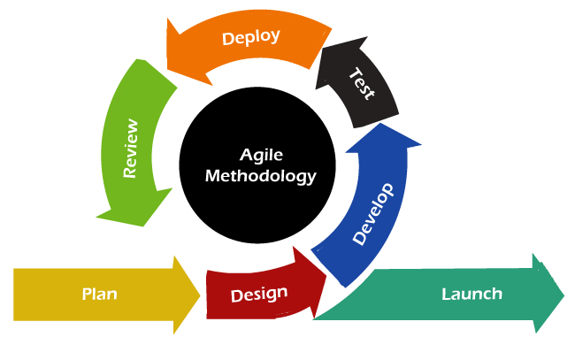
The Agile process model is preferred for developing an Electronic Cash Counter due to several reasons,
- Iterative and Incremental Development:
Agile promotes an iterative and incremental development approach. This allows for continuous refinement and improvement of the system based on user feedback.
- Flexibility to Changing Requirements:
Agile allows for flexibility in adapting to changes during the development process, ensuring the system aligns with the evolving requirements and market conditions.
- Frequent User Involvement:
Agile emphasizes regular collaboration with end-users. In the context of an Electronic Cash Counter system, involving users throughout the development process ensures that the system meets their needs, enhances usability, and aligns with regulatory requirements.
- Continuous Integration and Testing:
Agile encourages continuous integration and testing, allowing developers to identify and address issues early in the development cycle. This helps in ensuring the reliability and security of the software.
- Rapid Delivery of Value:
Agile focuses on delivering a minimum viable product (MVP) quickly. In the case of an Electronic Cash Counter, this means that essential functionalities can be delivered and deployed rapidly, allowing users to start benefiting from the system sooner.
- Adaptability to Risks:
The financial sector comes with inherent risks and uncertainties. Agile provides a framework for adapting to changes and managing risks effectively during the development process, ensuring that the system can respond to unforeseen challenges.
- Close Collaboration Between Teams:
Agile encourages close collaboration among cross-functional teams. For a complex system like an Electronic Cash Counter, this collaboration is essential as it involves integrating hardware, software, security measures, and compliance considerations.
- Customer Satisfaction:
Agile focus on customer satisfaction aligns with the goal of delivering a reliable and user-friendly Electronic Cash Counter system. Regular feedback and involvement of end-users contribute to a product that better meets their expectations.

Result:
Thus the problem statement has been defined, feasibility study has been explained in detail and the process model is finalized.

